1 Backpack
1 Art box
1 Package sticky-backed velcro
2 Boxes of Crayola Crayons- (Basic 8 colors)
4 Pencils #2
1 White Binder- 1” with clear plastic on cover
3 Glue sticks
2 Boxes of Sandwich Baggies
2 Box of Wet Wipes
1 spare set of clothes- accidents happen!

Thank you for all you do,
Mrs. Forthofer
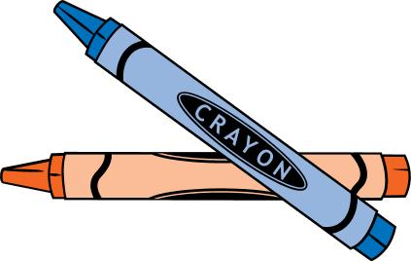

*If your child wears pull-ups, please send in a package & a note will come home when more are needed.

