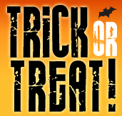

Clubs and organizations at the high school and junior high school level will host classrooms

with *candy and special surprises!*

There will be a *carnival* in front of the main office area.

This will include face painting and games.

There will also be a haunted house!

Please come out to G-CHS to support a great cause in a SAFE environment.

COSTUMED students of all ages welcome!

All children must be accompanied by a parent.

The cost is FREE but Student Council members will be collecting free-will donations for

Riley Children’s Hospital.

Monday, October 29th 5:30-7 p.m.